Audition Packet

Directed by: Barcia Miller Alejos

Producers: Jen Otterman and Ka’Lena Cuevas
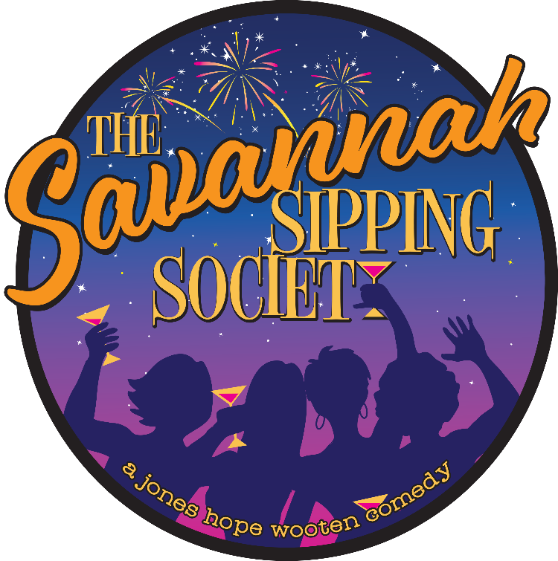

6 p.m. Sunday, December 2, 2018
7 p.m. Monday, December 3, 2018

The Belfry Theatre, 10690 Greenfield Ave., Noblesville, IN
Reservations: (317) 773-1085

ABOUT THE BELFRY THEATRE

In July of 1965, a collection of Noblesville residents who enjoyed gathering to read plays decided it was time to take their passion to the next step. That summer, Mrs. Anne Braswell, Mr. and Mrs. Frank Campbell, Mrs. and Mrs. Robert Kraft, Mr. and Mrs. John Kyle, Mrs. Shirley Pritchard, and their leader, the Rev. John Burbank, formed the Hamilton County Theatre Guild.

The Belfry Theatre is a friendly, welcoming place where those who wish to express their acting or other creative skills meet those who enjoy and appreciate quality productions of comedies, musicals, and dramas. Our goal is to attract and develop good actors and production personnel and showcase their talents in exceptional productions that will enrich and entertain our prospective audiences. We welcome diversity.

DIRECTORS FOR THIS PRODUCTION

Director: Barcia Miller Alejos
Assistant Director: Eric Matters
Producers: Jen Otterman and Ka’Lena Cuevas

Barcia Miller Alejos has been involved in community theater for the past 15 years as a director, assistant director, actress, and producer. She has been involved with The Belfry Theatre the last few years primarily as a producer, assistant director, and actress. Besides The Belfry, she has been involved in Mud Creek Players and the Scottish Rite Cathedral.

Eric Matters, an Encore Award-winning lighting designer, is stepping into the role of assistant director for this production.

Jen Otterman and Ka’Lena Cuevas will co-produce this production. Jen is a multiple Encore Award winner, and Ka’Lena is an Encore Award nominee.

WHO TO CONTACT

Production and audition inquiries: Director, Barcia Miller Alejos – barciaalejos@gmail.com

Show Dates and Venue

Eight shows over three weekends at The Belfry Theatre, 10690 Greenfield Ave., Noblesville IN

8 p.m. Fridays, Feb. 1, 8, 15
8 p.m. Saturdays, Feb. 2, 9, 16
2 p.m. Sundays, Feb. 10 and 17.

Call will be at least 90 minutes prior to show time.

Audition Notes

Audition times: 6 p.m. Sunday, Dec. 2, 2018, and 7 p.m. Monday, Dec. 3, 2018
10690 Greenfield Ave., Noblesville IN

Audition form, included at the end of this packet, should be completed prior to the audition. If you are unable to complete the form prior to the audition, please arrive early to complete it.

Bring a headshot if you have one, and attach it to the audition form. If not, one will be taken at the audition.

All actors will be notified by 9 p.m. Saturday, Dec. 8, either by email or phone.

Audition

There will be readings from the script.

You also need to prepare a monologue from one of the four audition selections of the script (attached).

Rehearsals

Rehearsals will begin Monday, Dec. 10, 2018. Rehearsals will be 7 p.m. to 9:30 p.m.

Rehearsal schedule:

Monday through Thursday, Dec. 10-19, 2018, from 7 p.m. until 9:30 p.m.

Rehearsals will reconvene on Jan. 2, 2019, and will run until Jan. 24, 2019, and follow the Monday-through-Thursday schedule.

Tech schedule:

Tech Saturday will be all day from 10 a.m. to 5 p.m. on Jan. 26, 2019.

Tech Week will be Monday, Jan. 28 through Thursday, Jan. 31 with call at 6:30 p.m. for full runs of the show.

Full makeup and costumes are required beginning Jan. 26 and until Opening Night.

During the three-week run of the show, there will be brush-up rehearsals on Thursday, Feb. 7, and Wednesday, Feb. 13.

Any expected absences for rehearsals should be noted on the audition form. No absences are allowed during the run of the show.

SYNOPSIS

While written as a delightful laugh-a-minute comedy that Jones, Hope, and Wooten are known for, The Savannah Sipping Society has depth and poignancy that touches on the true meaning of friendship and what it means when circumstances force us to adjust to the uncomfortable changes and twists and turns that life brings.

We meet four unique Southern women: Randa, Dot, Marlafaye and later, Jinx, their new “life coach.” They agree to meet on Randa’s verandah on Friday nights for cocktails. They all desire to escape the sameness of their day-to-day routines, as they each are going through a dramatic and difficult change in their life. They are each very different people with seemingly nothing in common, but are drawn together by fate and an impromptu happy hour! With a little encouragement, they decide it’s time to reclaim the enthusiasm for the life they’ve lost throughout the years. Over the course of six months, which are filled with laughter, hilarious misadventures, and the occasional liquid refreshment, these middle-aged women successfully bond and find the confidence to jumpstart their new lives. Together, they discover lasting friendships and a renewed determination to live in the moment. Most importantly, they realize it’s never too late to make “old friends” new. So, raise your glass to these strong women and their fierce embrace of life and say, “Cheers!” to this joyful and surprisingly touching Jones, Hope, and Wooten comedy!

Characters

Randa Covington (stage age 49) Randa is a perfectionist and workaholic, struggling to cope with a surprise career derailment that, unfortunately, reveals that she has no life and no idea how to get one.

Dot Haigler (stage age 69) Dot is still reeling from her husband’s recent demise and the loss of their plans for an idyllic retirement. She also faces the unsettling prospect of starting a new life from scratch — and all alone.

Marlafaye Mosley (stage age 57) Earthy and boisterous, Marlafaye is a good ol’ Texas gal. She has blasted into Savannah in the wake of losing her tom-cattin’ husband to a 23-year-old dental hygienist. The strength of her desire to establish a new life is equaled only by her desire to wreak a righteous revenge on her ex.

Jinx Jenkins (stage age 53) Also new to town, Jinx, a spunky ball of fire, offers her services as a much-needed life coach for these women. However, blinded by her determination and efforts to get their lives on track, she overlooks the fact that she’s the one most in need of sage advice.

Randa’s Grandmother (non-speaking role; stage age 81) Grandmother of Randa who appears and dies. Elegant matriarch of powerful, southern family.

The Savannah Sipping Society Monologue Selection
***Please choose one of the following four options for your audition***

RANDA COVINGTON
It’s been said, “The more you complain, the longer God makes you live.” Grandmother died on her 91st birthday — obviously even He couldn’t take it anymore. Come to find out she had every cardiac issue imaginable, but, being Grandmother, she didn’t bother telling anyone in the family about it. Frankly, it was a surprise to me to find out she had a heart. But die she did, and this began the endless tributes over the past six weeks that elevated her in death, to sainthood. Being the dutiful doormat granddaughter, I showed up for all of it —- the wake, the funeral, the memorial, the renaming of the park, and, today, the final indignity, the reading of the will. And because no Covington Family gathering is complete without “helpful” comments on my unrelenting single status, my eccentric Aunt Juliette cornered me with more words of wisdom. She said, “Miranda, darling, you must keep this in mind — it’s important to have a man in your life who can repair things; it’s important to have a man in your life who can make you laugh; it’s important to have a man in your life who’s good in bed. (Lower.) And it’s very important that these three men never meet, or you could end up dead.” (Sighs.)

DOT HAIGLER
Ross was always fond of saying, “Never ask a question if you really don’t want to know the answer.” Kind of like when the preacher’s wife asked the little girl, “And why are we quiet in church?” The little girl whispered, “So we don’t wake anybody up.” (Laughs.). So, when I went to the specialist — well, three specialists, but who’s counting — I knew the answer to my question wouldn’t be a good one, but the phrase “going blind” was not one I’d counted on hearing. I couldn’t have faced this on my own....and I am so lucky I don’t have to. (Rallies. Pleasant, no trace of self-pity.). Heavens, I’ve been around quite a while, maybe I’ve just seen my share. I’ve started memorizing faces, studying maps, trying to remember images of all the things I don’t want to forget. So, time for me to adapt and change.
MARLAFAYE MOSLEY
Absolutely! And any joker knows “drink responsibly” means don’t spill it! (Laughter.) I guess this is the way it happens — life, that is. One day you’re locked in a sweatbox so with some health nuts thinking” you’re either gonna blow your groceries or stroke out. Next thing you know, you’ve got yourself a handful of potential friends. Funny how that works. It’s been a few months since we started gettin’ together and I gotta say, all four of us seem to be “re-energizing” our lives —- which is a loosely-goose way of sayin’ “gettin off our cans and takin’ care of business.” ‘Course Jinx forcin’ the four of us to traipse off to the opera one night was nothin’ but a bust. I mean, who sings for 20 minutes when they’re dyin’?! And it wasn’t even English! Other than that, it’s all been pretty good.

JINX JENKINS
Okay, this would be a good example of why I get to be the life coach and you two don’t (Randa, Dot and Marlafaye exit.). Randa continued to be a little doubtful about my idea of the birthday party. But eventually, she got on board and we threw ourselves into it, spent the week getting ready for the big do in Randa’s elegant dining room —- we laid in caviar, the finest oysters, salmon mousse, all of her old granny’s faves. Oh, and champagne, of course —- doesn’t hurt knowing a certain Texan who gets a steep discount. And I’ve got a great feeling about this. We’ll have a ball and maybe, just maybe, Randa can finally win the old girl over. Look, I’m not kidding myself, it’s a serious responsibility when someone puts her trust in you, but I was born for this! And it’s a fantastic feeling that I might actually be able to help change people’s lives for the better...which is topped only by the thrill of getting good liquor on the cheap! Wooo-hoo!

The Belfry Theatre AUDITION/CONTACT FORM
Please fill out as much of the requested information below as possible, or circle or check the appropriate choice where applicable.

PLEASE PRINT CLEARLY

Full Name

Home Address ____

Primary Phone Secondary Phone ____

Email Address Facebook page name _____

Best way to contact you? Email ____ Phone _ Facebook Sex: Male Female ____

Hair Color Willing to change hair color/style? Yes No Birthdate : ____

Shirt size Height Waist Inseam Shoe Size ____

Theater Experience (continue on back or attach resume)
SHOW ROLE THEATER YEAR

Preferred Role ____________________________________________
If not cast, would you consider another role? Yes No
Schedule Conflicts: Please review the rehearsal and production schedule. List your known conflicts: ____________________________________________
If not cast in this production, which crew activities can you help with? (Please circle)
Set construction Stage crew Set decoration (painting) Costuming Props Tech crew
How did you hear about auditions? ____
Any additional information you would like to share?

THE BELFRY CONSENT FORM

Parent/Guardian’s Consent for Auditionees under 18
I give permission for my child to audition for The Savannah Sipping Society and I acknowledge and accept the conditions. I consent to my child performing in this production and if selected, I acknowledge it is my responsibility to ensure my child attends rehearsals and performances as required for this production.

I accept the responsibility that parents will be expected to be involved with the production in some form as a backstage assistant and/or in charge of children’s safety and supervision.

Signature of Parent/Guardian: Date:

All Actors: Permission to Use Name, Pictures, or Other Identifying Information
There are times when Play Directors and Board Members feel it is appropriate to recognize cast members and their work in a public forum. Examples of such recognition include but are not
limited to: publishing actor’s names, photographs, and/or displaying aspects of their work on The Belfry Theatre/ Hamilton County Theatre Guild website and/or other media. Cast members photos, and likeness may also be used on promotional posters, Facebook pages, and/or printouts.

These printed documents will be used to promote the theater either by promoting the production directly or The Belfry Theatre/Hamilton County Theatre Guild as a whole.

By signing below, you agree to allow The Belfry Theatre/ Hamilton County Theatre Guild to use your photo or likeness in the above described material however they see fit for the betterment of The Belfry Theatre/ Hamilton County Theatre Guild.

Signature of actor (or Parent/Guardian, if under age 18): Date:

